**TASK 2**

def pin_code():

Attempts = 3

correctPin = 9876

while Attempts >= 1:

pin = int(input('Enter Your PIN: '))

if pin == correctPin:

break

else:

print('Incorrect Pin. Try again: ')

Attempts -= 1

while Attempts <= 0:

print('Exit')

exit()

if __name__ == "__main__":

pin_code()

def withdraw():

print('Welcome')

try:

amount = float(input('Enter the amount to withdraw: '))

balance = 100

if (amount > balance) :

raise Exception

else:

balance -= amount

print('Remaining Amount in Account: $'+str(balance))

except Exception:

print('The amount cannot be greater than the balance')

if __name__ == "__main__":

withdraw()

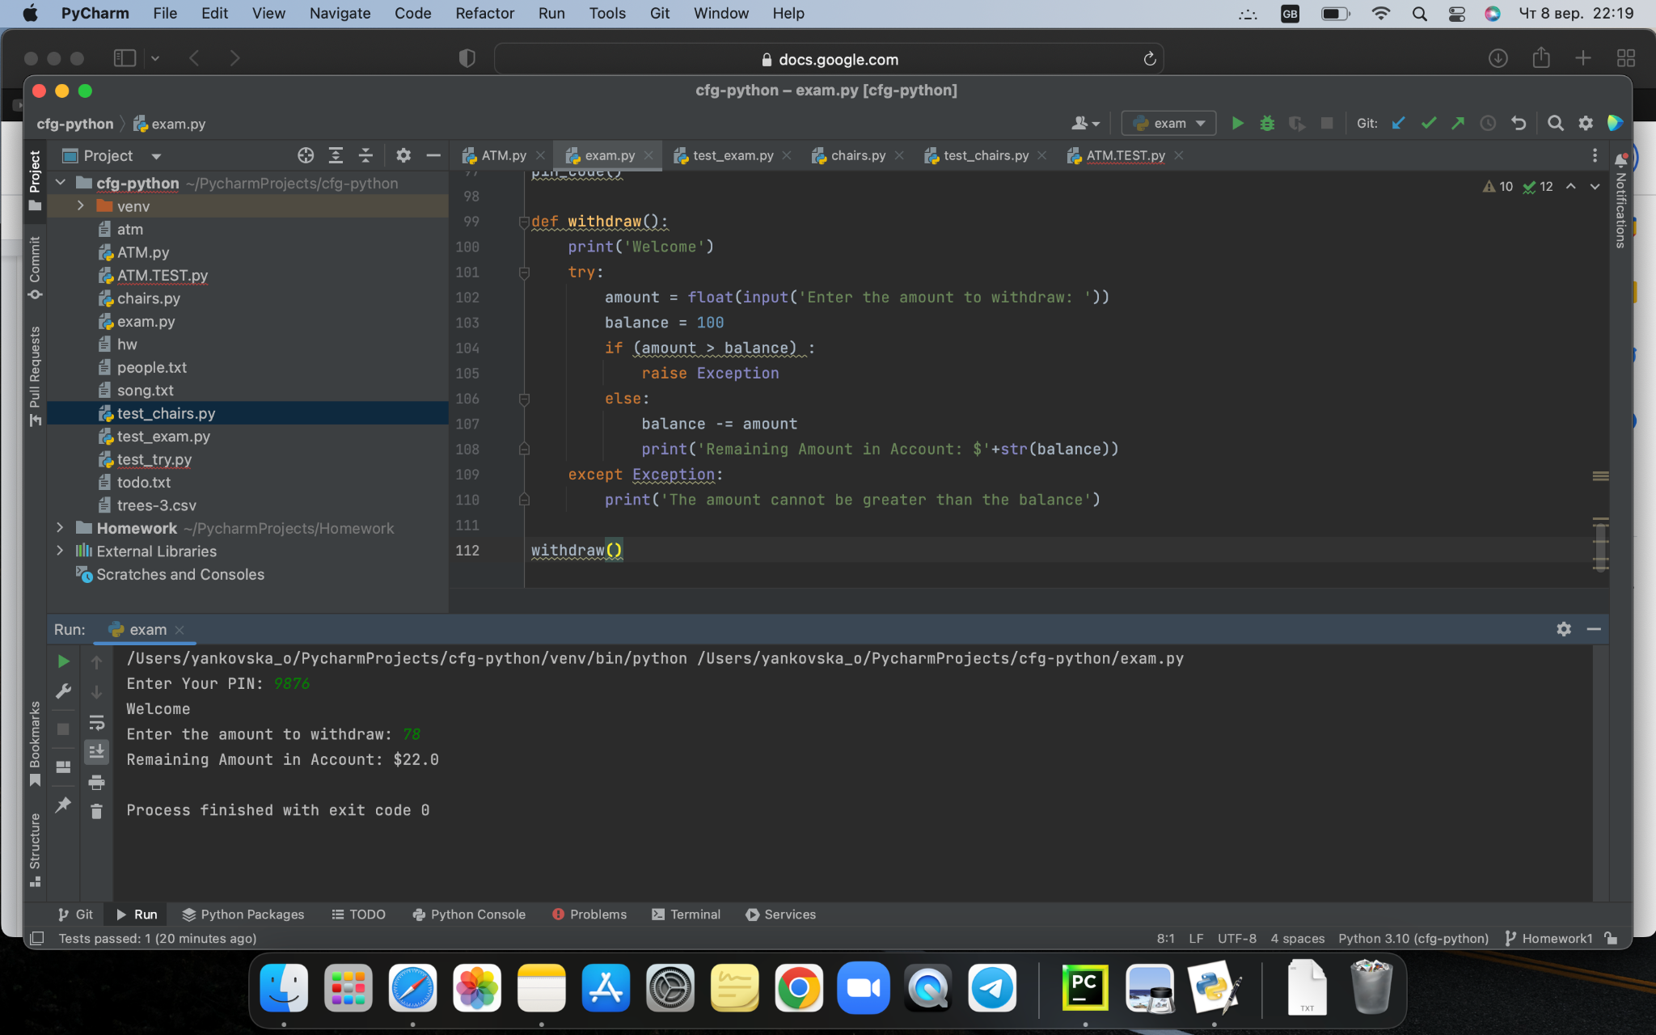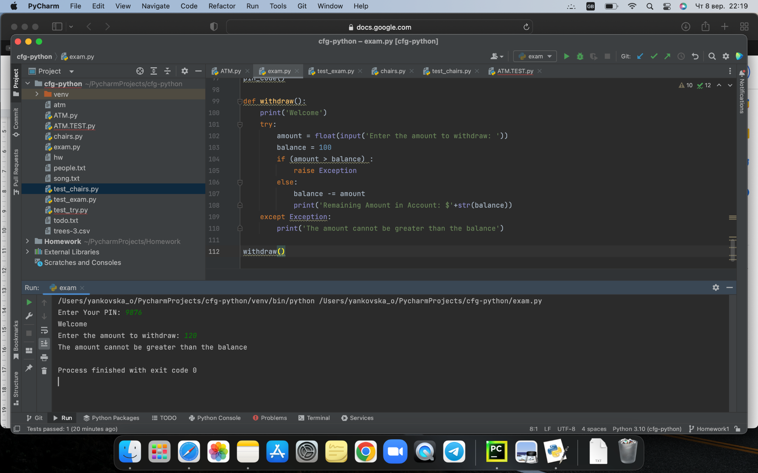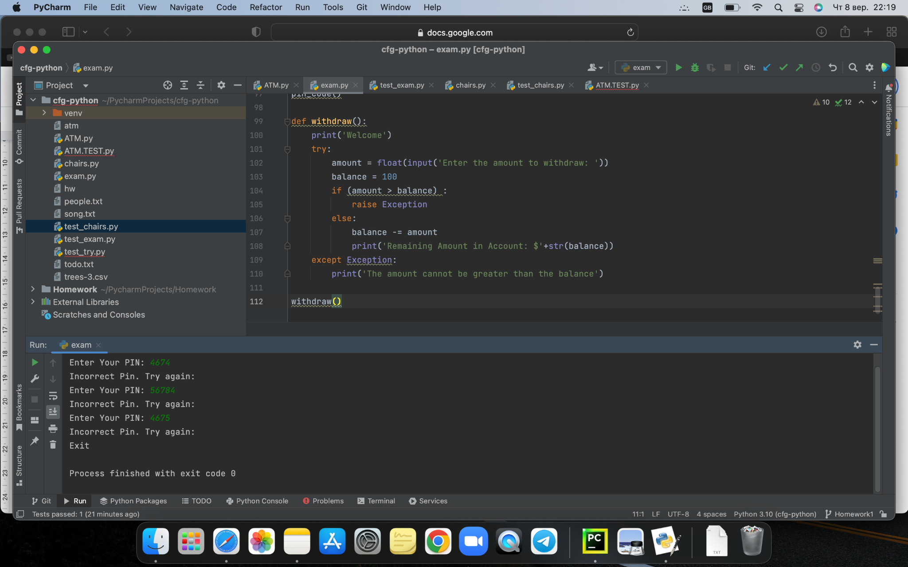

**TASK 3**

from unittest import TestCase

from exam import pin_code

class Test(TestCase):

def test_pin_code(self):

expected = 9876

result = pin_code()

self.assertEqual(expected, result)

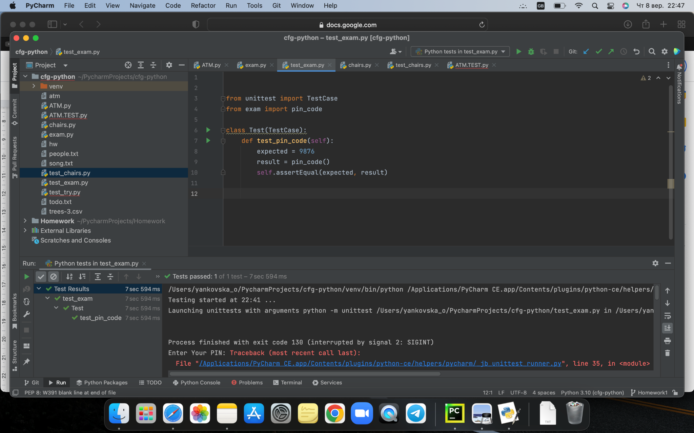

___________________________________________________________________

def amount_n(amount):

balance = 100

if (amount > balance) :

raise Exception

else:

return balance - amount

if __name__ == "__main__":

amount = print(amount_n(int(input(('Enter the amount to withdraw')))))

from unittest import TestCase

from exam import amount_n

class Test(TestCase):

def test_amount(self):

expected = 97

result = amount_n(amount= 3)

self.assertEqual(expected, result)

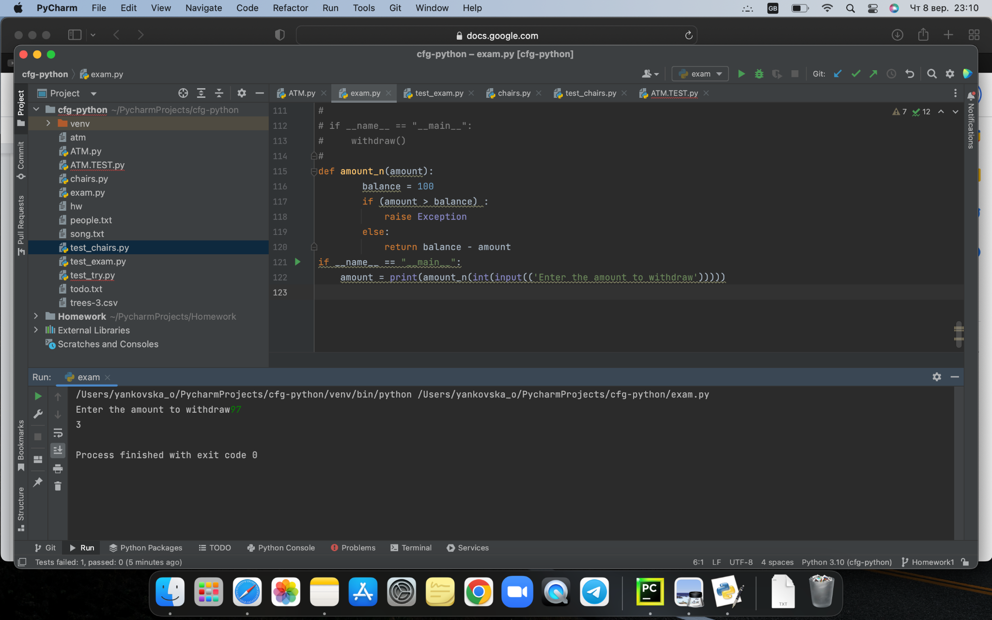

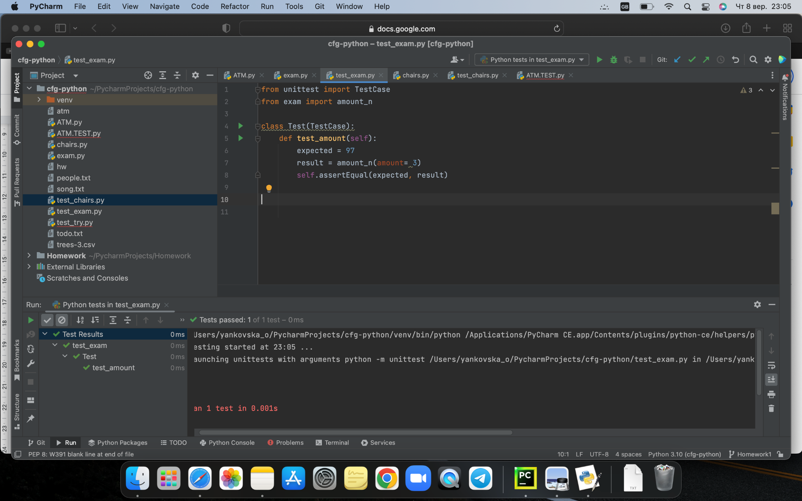from unittest import TestCase

from exam import amount_n

class Test(TestCase):

def test_amount(self):

expected = 93

result = amount_n(amount= 3)

self.assertEqual(expected, result)

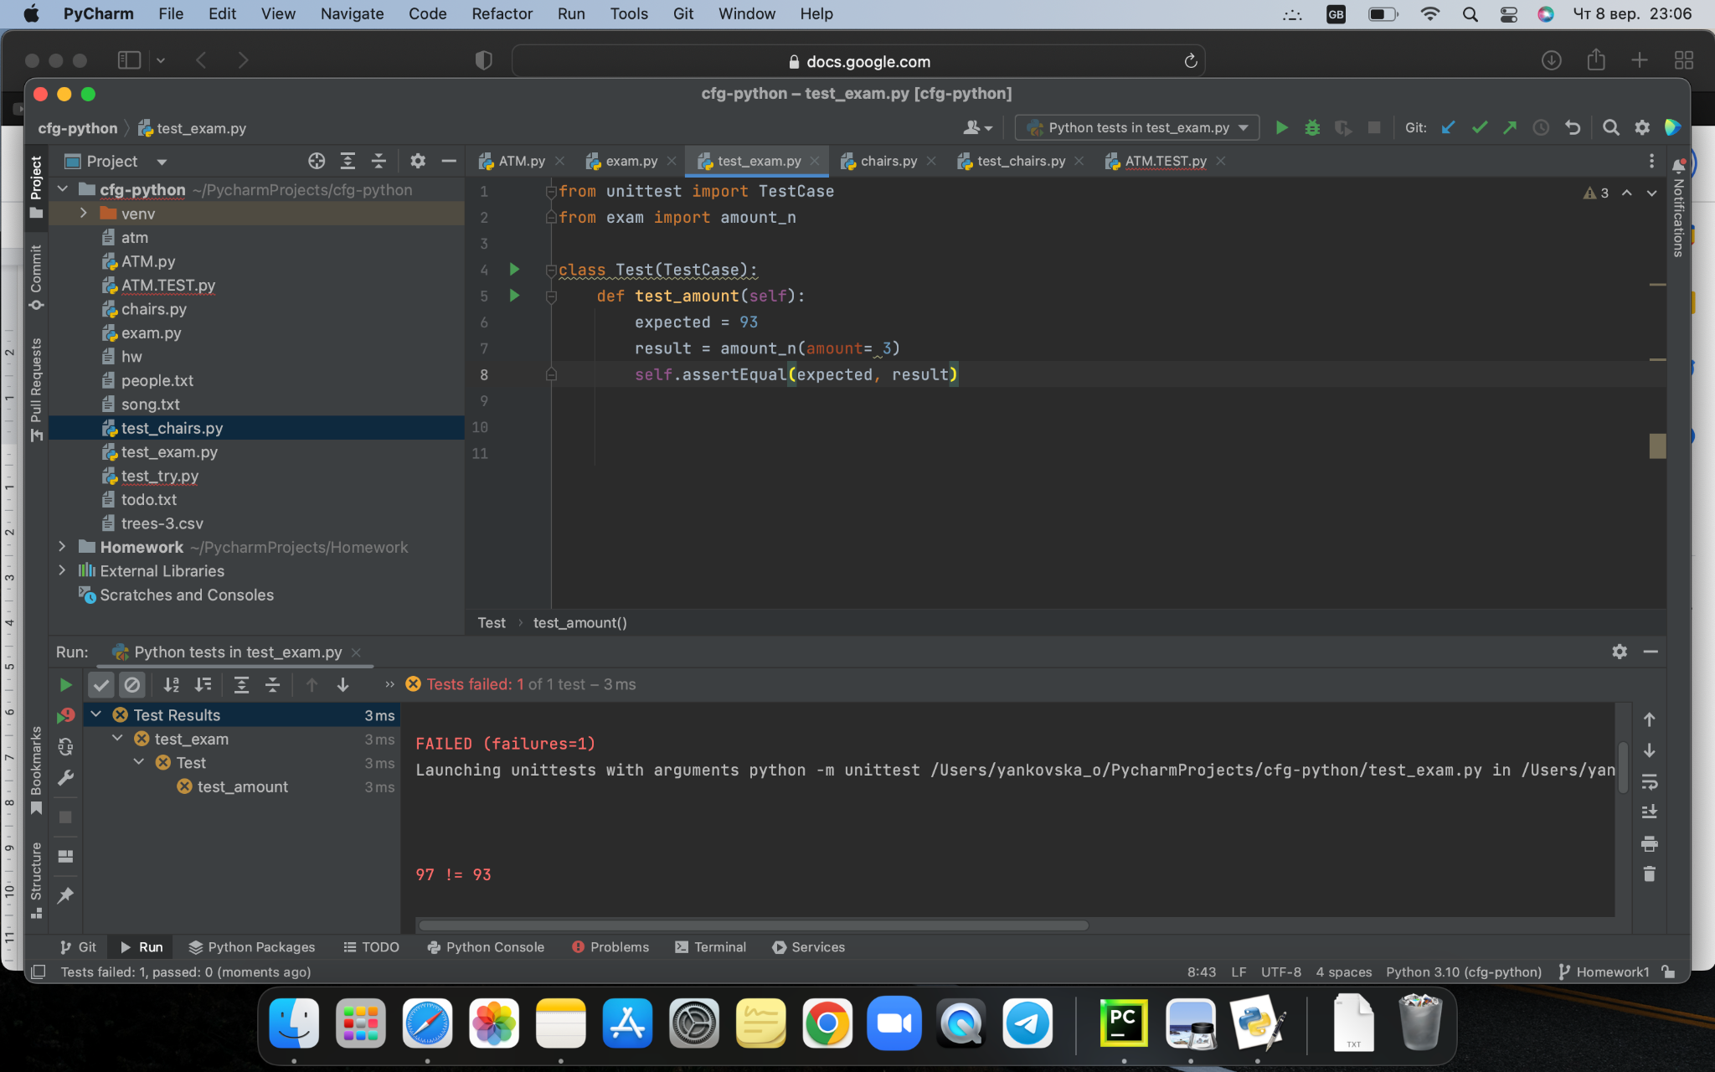

_________________________________________________________________

def correct(pin):

correctpin = 9876

if pin == correctpin:

return 'green'

else:

return 'red'

if __name__ == "__main__":

print(correct(int(input(('pin')))))

from unittest import TestCase

from exam import correct

class Test(TestCase):

def test_correcr(self):

expected = 'red'

result = correct(pin= 5748)

self.assertEqual(expected, result)

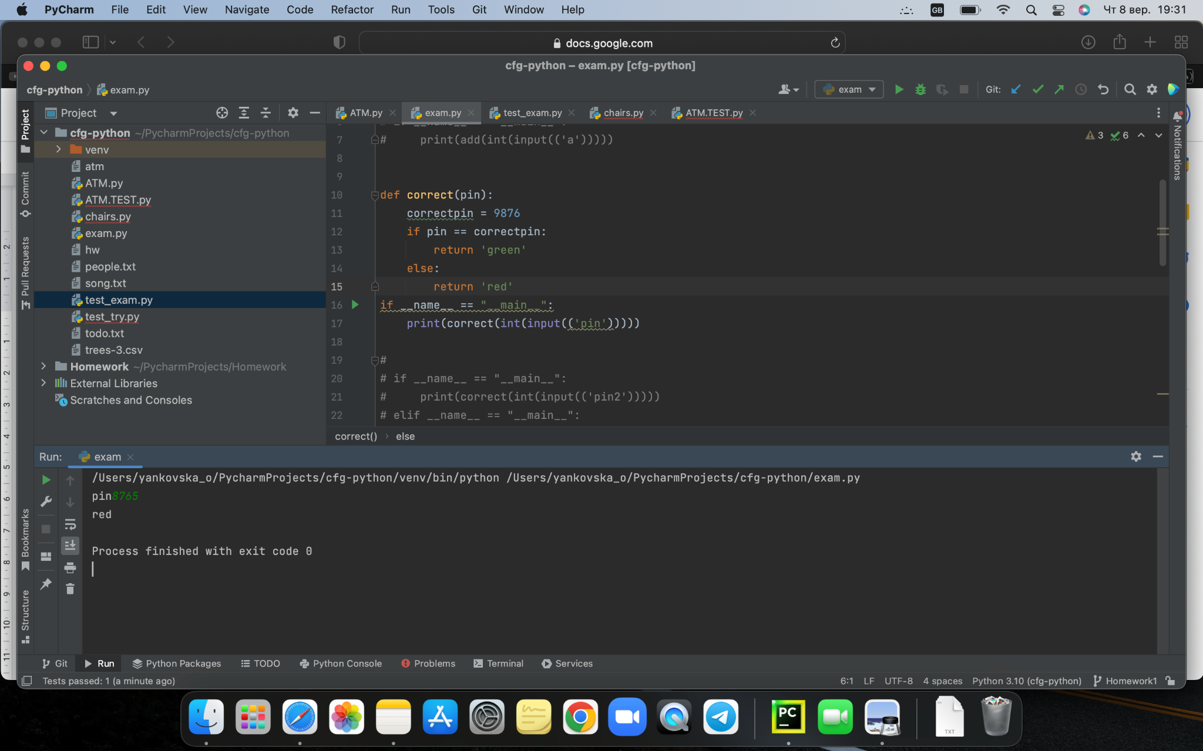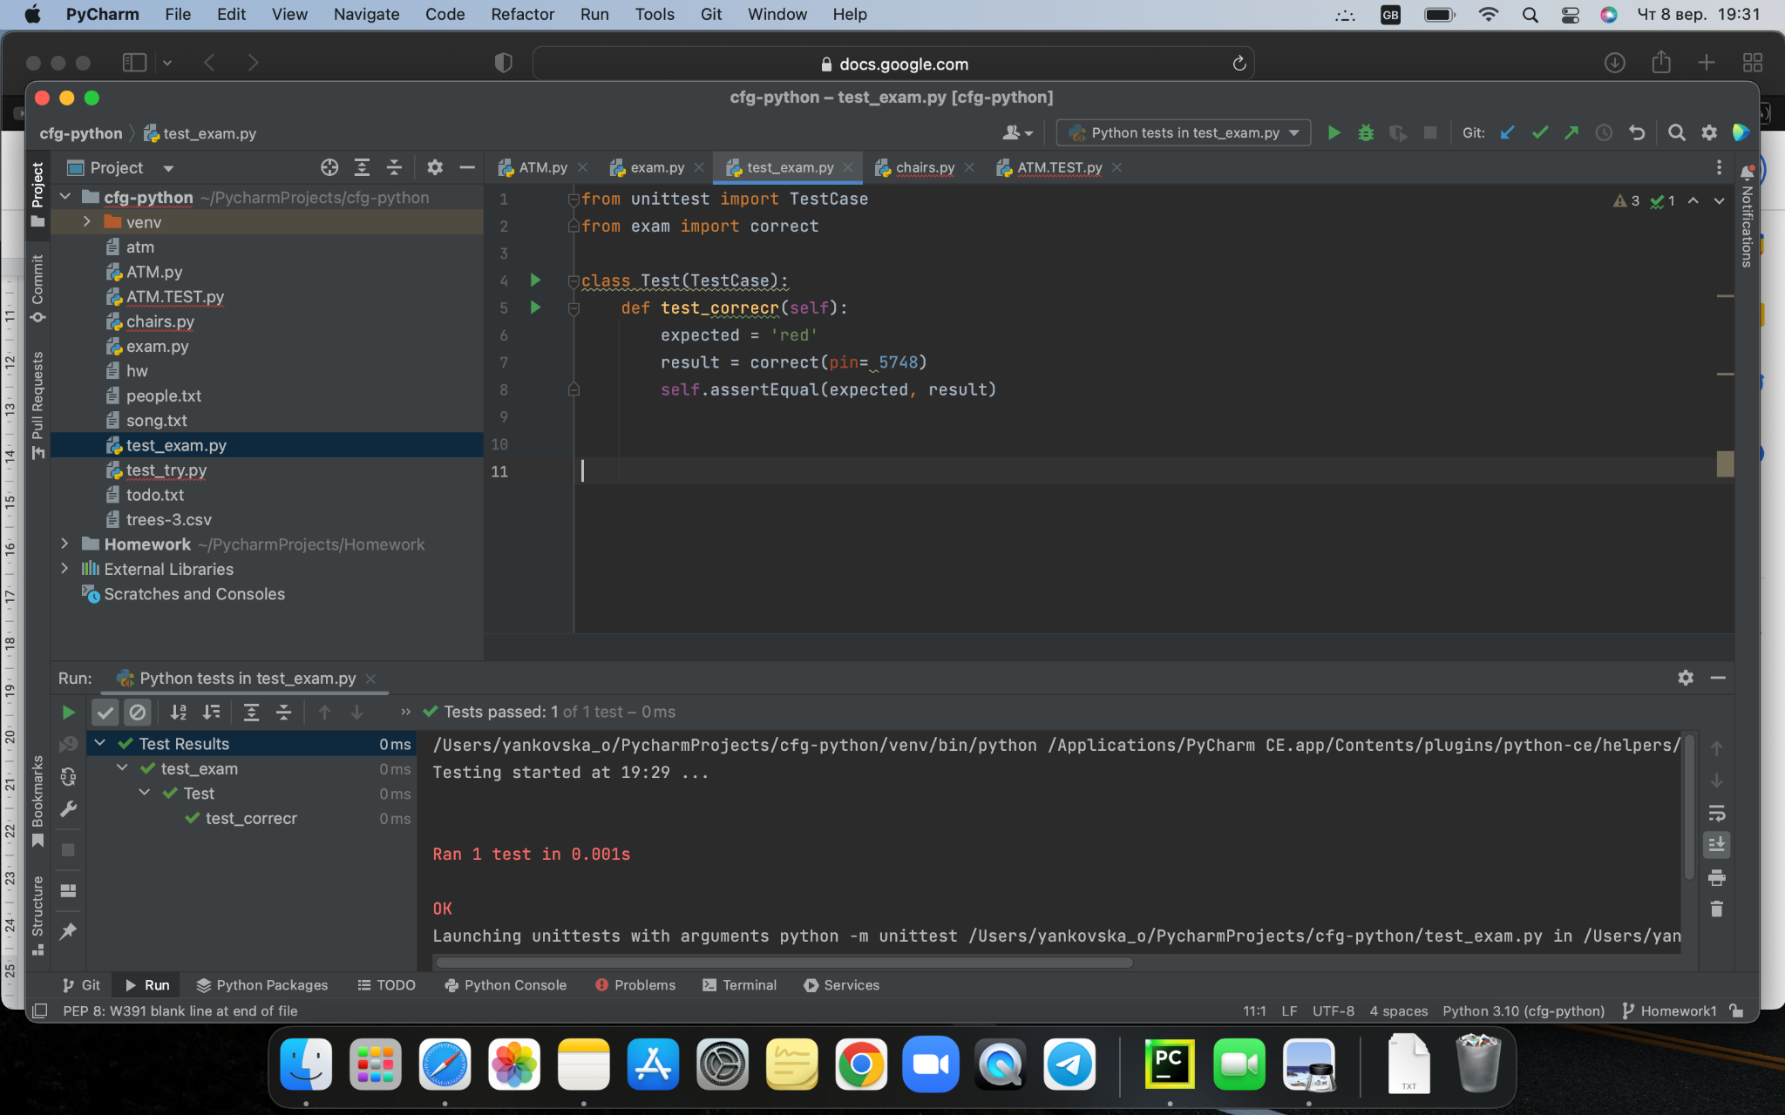

from unittest import TestCase

from exam import correct

class Test(TestCase):

def test_correcr(self):

expected = 'green'

result = correct(pin= 5748)

self.assertEqual(expected, result)

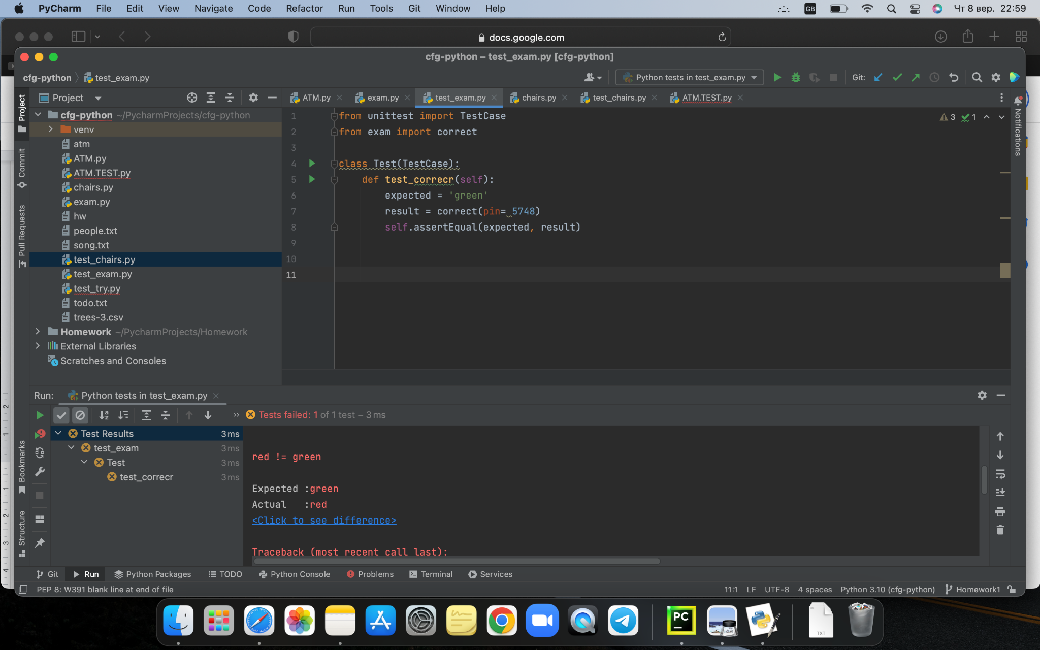

from unittest import TestCase

from exam import correct

class Test(TestCase):

def test_correcr(self):

expected = 'red'

result = correct(pin= 9876)

self.assertEqual(expected, result)

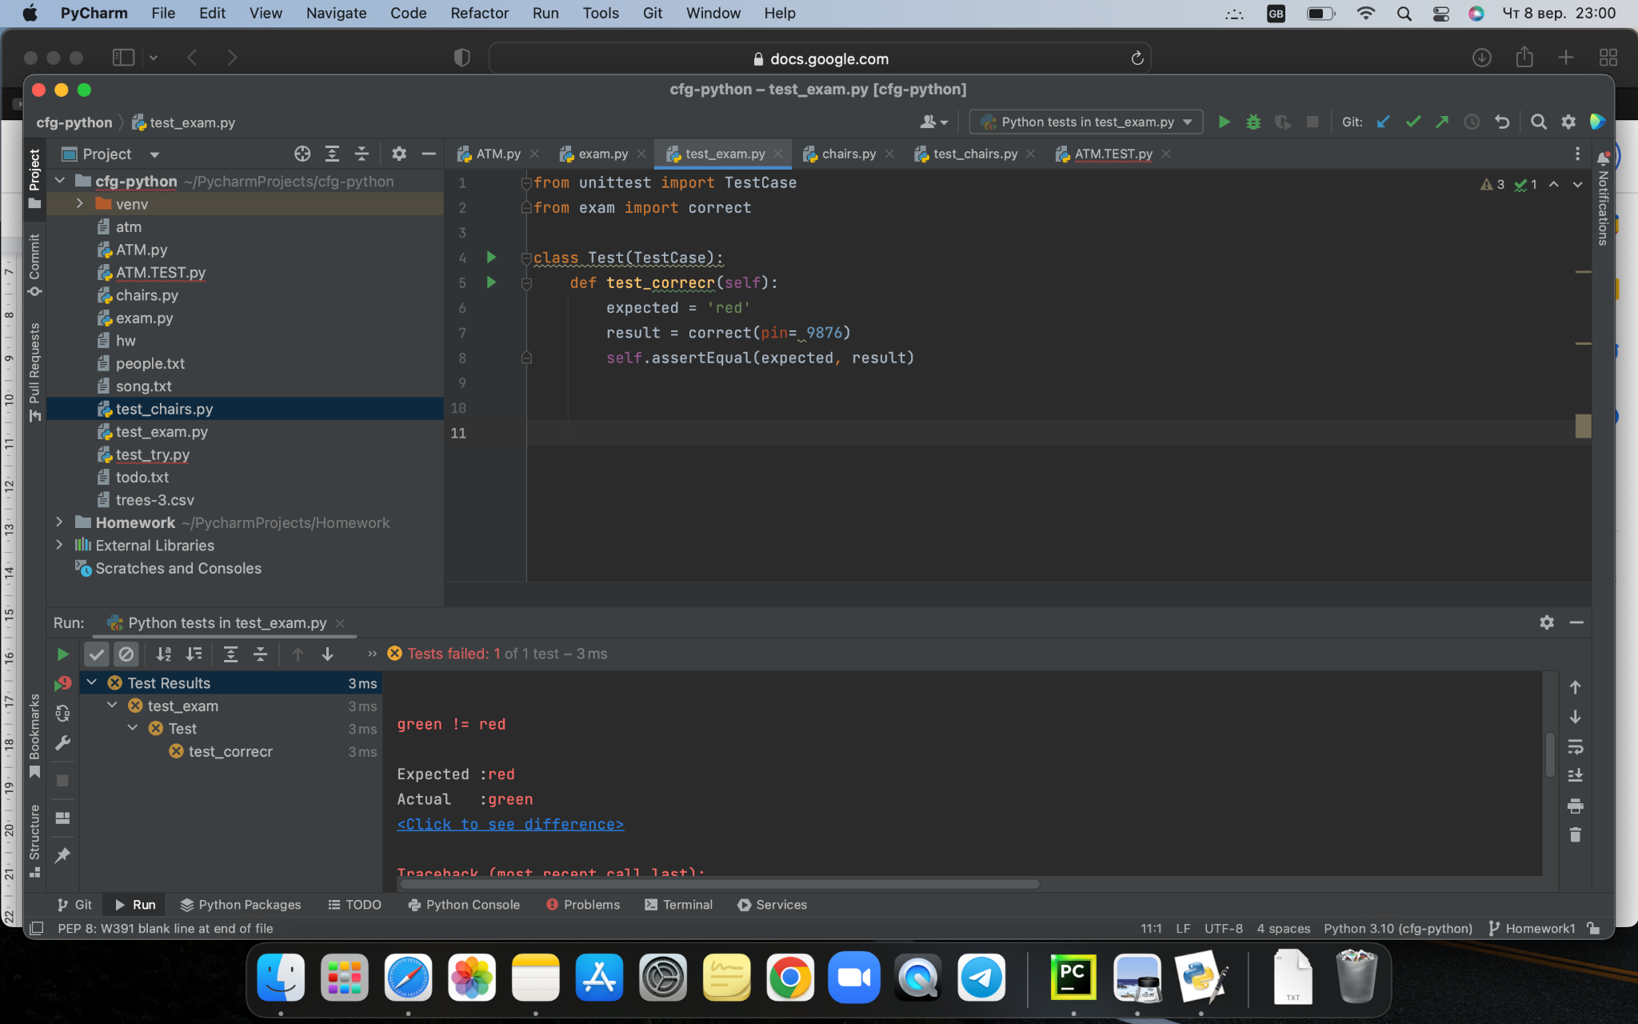

__________________________________________________________________

def yes_or_no():

pin = input("Enter pin: ")

if pin == 9876:

return "welcome"

elif pin != 9876:

return "go away"

yes_or_no()

from unittest import TestCase, mock

from exam import yes_or_no

class Test(TestCase):

def test_pass(self):

with mock.patch('builtins.input', return_value=9876):

assert yes_or_no() == "welcome"

with mock.patch('builtins.input', return_value=4657):

assert yes_or_no() == "go away"

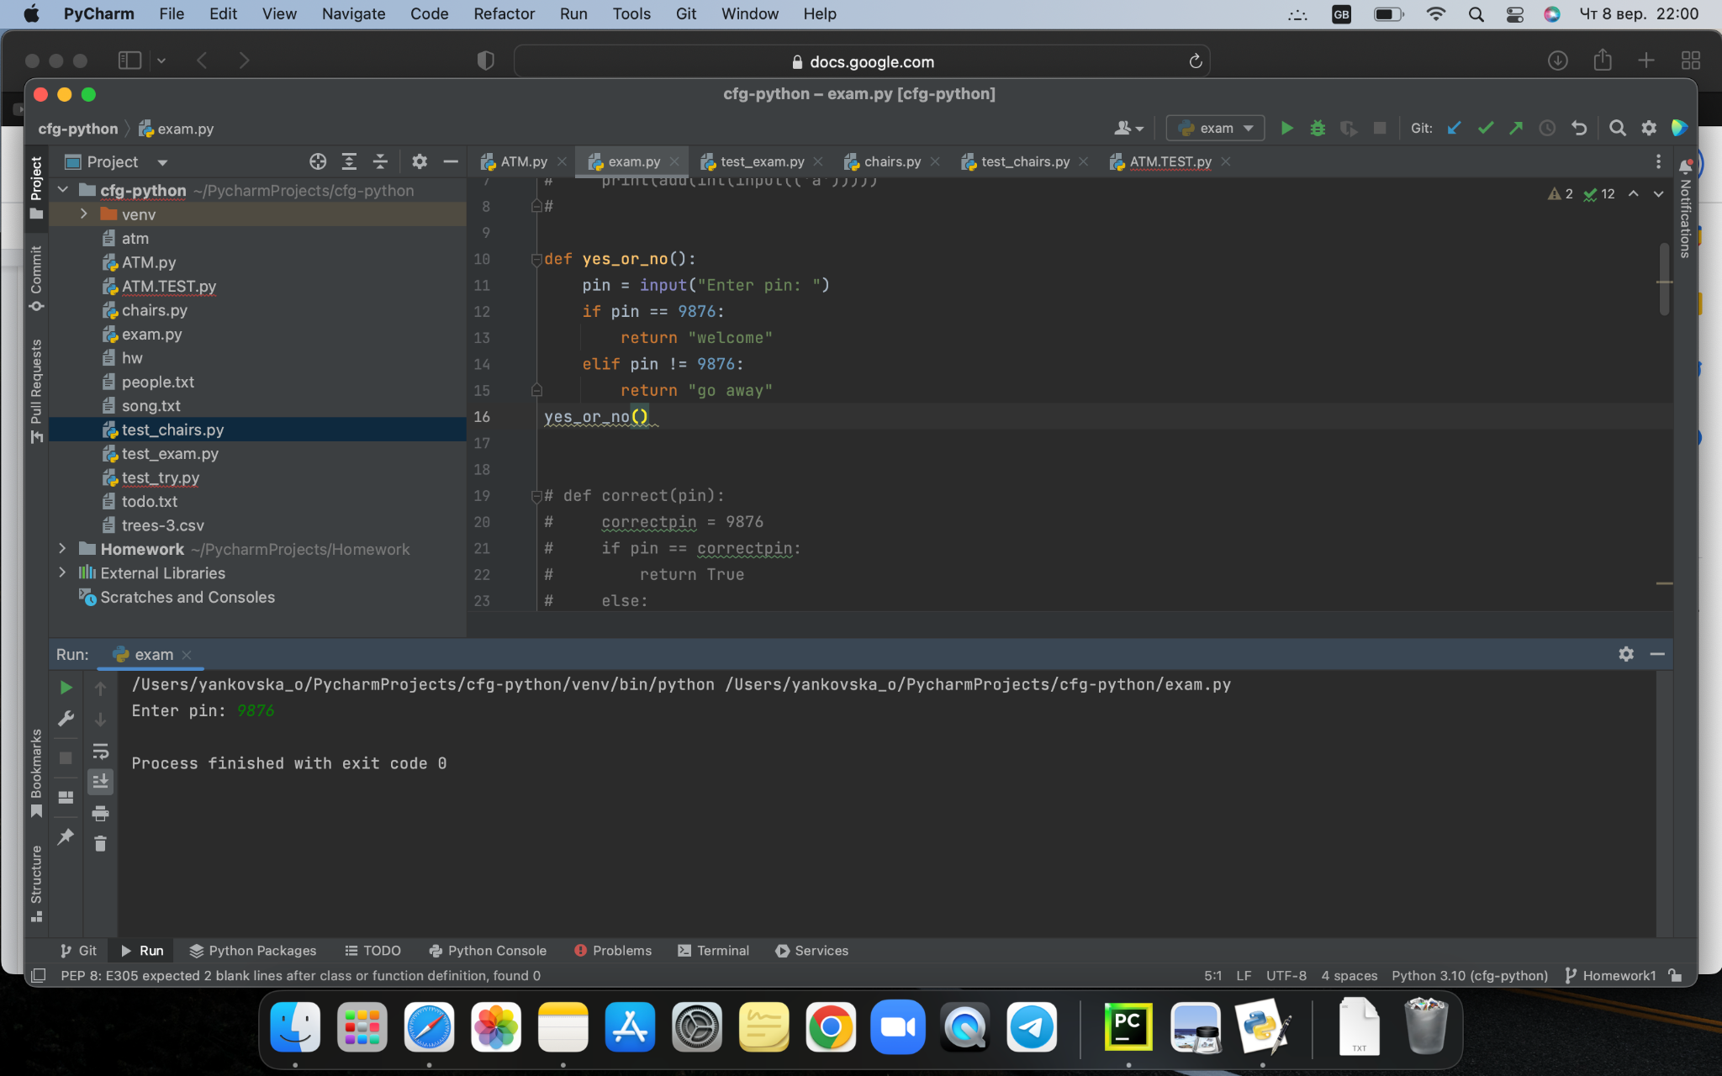

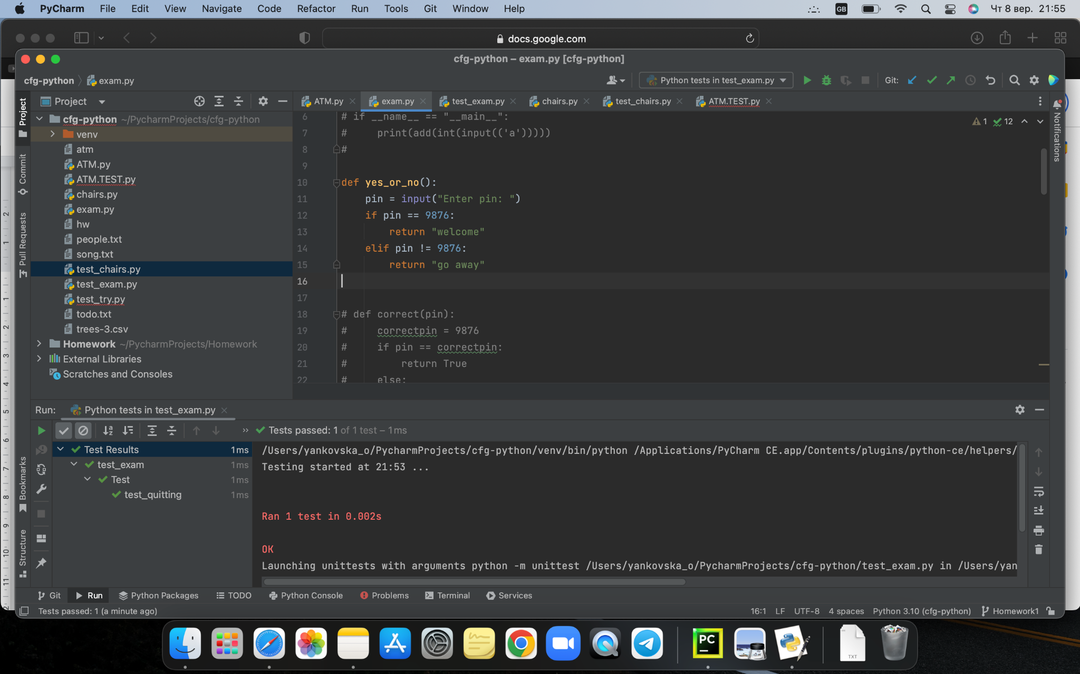

from unittest import TestCase, mock

from exam import yes_or_no

class Test(TestCase):

def test_pass(self):

with mock.patch('builtins.input', return_value=9876):

assert yes_or_no() == "welcome"

with mock.patch('builtins.input', return_value=7654):

assert yes_or_no() == "welcome"

